84
Kansas History
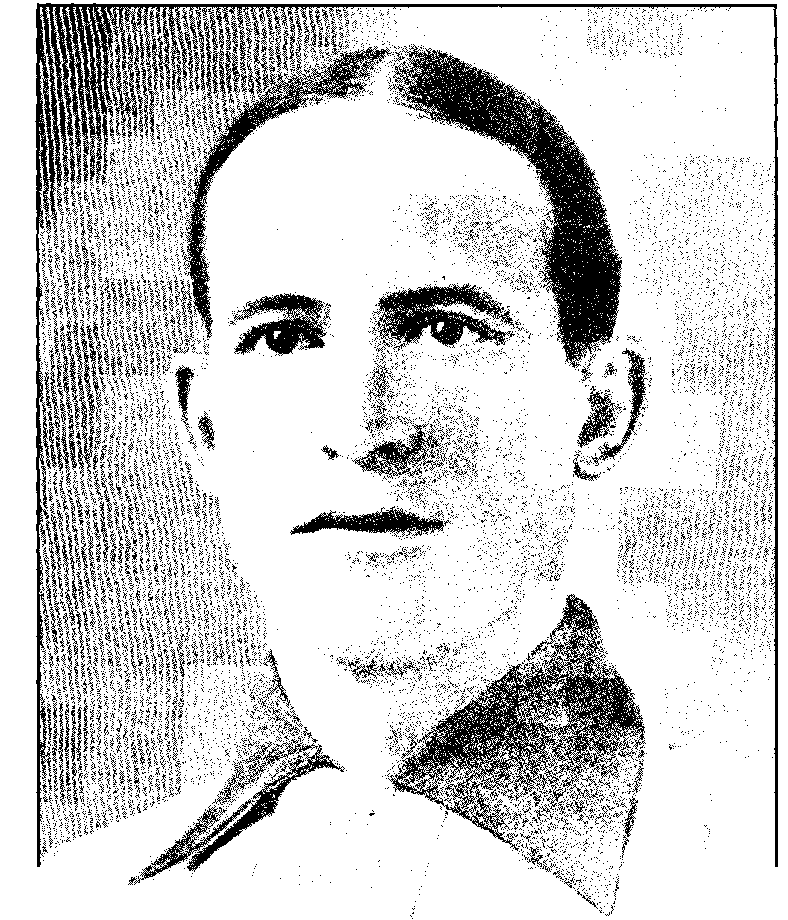
Fred Clarke, now in baseball's Hall of Fame was a successful player and club manager.
out, was the hardest man to beat that ever sent a ball flashing over the plate.""
Also in baseball's Hall of Fame is Fred Clarke, a true baseball pioneer. He was exceptionally well-rounded in all phases of the game-hitting, fielding, and managing. At the age of twenty-four he became the first successful "boy manager."" His career as a player-manager lasted for twenty-one years, all but six of those years spent with the Pittsburgh Pirates.
He was born on a farm near Winterset, Iowa, on October 3, 1872. In 1874 he and his family moved to Kansas by covered wagon. Two older brothers had earlier settled in Winfield and urged the family to make the move to the beautiful valley of the Walnut River. The family settled on a farm four miles north of Winfield."
18. Grantland Rice, "The Coffeyville Express," Collier's 77 June 5, 1926): 21.
19. Hall of Fame plaque inscription, Fred Clarke clipping file, library, Kansas State Historical Society.
20. Frederick C. Lieb, "Fred Clarke," Baseball Magazine (February 10, 1910): 47; Judy Welch, "Cowley County's Fred Clarke Brought Fame, Glory to Pittsburgh Pirates," Arkansas City Traveler, November 8, 1976.
For reasons unknown, the family decided to go back to Iowa in 1880, and moved to Des Moines, taking up residence in the city. It was there that Fred first excelled at baseball. He starred for the Des Moines Mascots, which at the time was the foremost amateur team in town."
Clarke soon developed into a rather skilled player. In the winter of 1892, he saw an advertisement for baseball players in The Sporting News and considered inquiring. A friend of his, however, had already received favorable responses from a number of clubs and had an extra railroad ticket to try out with the Hastings team of the Nebraska State League. He offered it to Fred. Clarke's tryout went well and the club offered to pay him forty dollars a month .12 Despite the urgings of his parents to stay in college, he accepted the offer and set out in pursuit of a baseball career.
On June 26, 1894, Fred was purchased by the Louisville Colonels, then of the National League. His career at Louisville was brilliant. He was a consistent .300 hitter and in 1895 hit safely in thirty-one consecutive games. In 1897 he hit.402; that was the same year he was made player-manager, after only four years in the National League .21
When Col. Barney Dreyfuss purchased the Louisville Colonels in 1900, he consolidated the team into the Pittsburgh Pirates. In that consolidation such future Pirate greats as Clarke, Honus Wagner, Deacon Phillippe, and Tommy Leach came from Louisville. Clarke remained as the player-manager for the Pirates and enjoyed almost instant success. His team finished second in 1900 and first in 1901, 1902, 1903, and 1909.21 In 1903 the Pirates played in the first World Series and lost to the Boston Red Sox five games to three. However, in 1909, Clarke got his revenge on the American League by beating the Detroit Tigers and their star, Ty Cobb, four games to three. Clarke played a significant role in his team's success by hitting two home runs and driving in seven runs in the series.
Known as "Cap" or "Fearless Fred," Clarke was regarded as one of the greatest outfielders of his day and led the National League in fielding percentage for his position as a left fielder. He excelled with the bat as well as the glove as his .315 lifetime batting average
21. Lieb, "Fred Clarke," 47. Clark lived in Winfield in later years and died there in 1960.
22. Welch, "Cowley County's Fred Clarke," 10; Fred Clarke clipping file, The Sporting News, St. Louis, Missouri.
23. Clarence W. Miller, "Fred Clarke-Ball Player, Ranchman Kansan," Kansas Magazine 2 (November 1909): 47-48; "Fred Clarke Is Dead," Kansas City Times, August 15, 1960, Athletes clipping file, Library, Kansas State Historical Society.
24. Lieb, "Fred Clarke," 48.

